**Critical Thinking Assignment Module One Assignment**

**Console Application and Syntax Correction**

Victor Enogwe

Computer Science, Colorado State University - Global Campus

CSC450-1: Programming III

Reginald Haseltine

April 19, 2024

In this module, we’ve introduced the C++ language, explored setting up our development environment, wrote basic C++ programs using variables and classes, and learned about the SEI CERT C++ coding standards.

I created a simple C++ console program that implements a “FictionalPerson” class with members' first name, last name, street address, city, and zip code and a “toString” method that prints out these details.

I also fixed the two C++ files which had errors.

**Fictional Person Pseudocode**:

PROGRAM Automobile

- This program creates a fictional person class with methods to get color, make and model

BEGIN

BEGIN

create a FictionalPerson.h Class declaration header file.

declare a constant class private member "firstName" variable to store the firstName of the person.

declare a constant class private member "lastName" variable to store the lastName of the person.

declare a constant class private member "streetAddress" variable to store the street address of the person.

declare a constant class private member "city" variable to store the city of the person.

declare a constant class private member "zipCode" variable to store the zip code of the person.

declare a class private method "setFirstName" which takes a validly named constant string parameter as an argument and returns void to set the firstname of the person.

declare a class private method "setLastName" which takes a validly named constant string parameter as an argument and returns void to set the lastname of the person.

declare a class private method "setStreetAddress" which takes a validly named constant string parameter as an argument and returns void to set the street address of the person.

declare a class private method "setCity" which takes a validly named constant string parameter as an argument and returns void to set the city of the person.

declare a class private method "setZipCode" which takes a validly named constant string parameter as an argument and returns void to set the zip code of the person.

declare a class public method "getFirstName" which returns a constant - the firstname of the person.

declare a class public method "getLastName" which returns a constant - the lastname of the person.

declare a class public method "getStreetAddress" which returns a constant - the street address of the person.

declare a class public method "getCity" which returns a constant - the city of the person.

declare a class public method "getZipCode" which returns a constant - the zip code of the person.

declare a class public method "toString" which returns a constant - a string concatenation of the firstname, lastname, street address, city and zip code of the person.

declare a class constructor that accepts the firstName, lastName, streetAddress, city, zipCode as parameters.

The body of the constructor should set the corresponding class member variables to the parameter values using the corresponding setter methods.

END

BEGIN

create the FictionalPerson.cpp Class definition implementation cpp file.

define a class private method "setFirstName" which takes a validly named string parameter as an argument and returns void, setting the firstName member variable of the class to this parameter.

define a class private method "setLastName" which takes a validly named string parameter as an argument and returns void, setting the lastName member variable of the class to this parameter.

define a class private method "setStreetAddress" which takes a validly named string parameter as an argument and returns void, setting the streetAddress member variable of the class to this parameter.

define a class private method "setCity" which takes a validly named string parameter as an argument and returns void, setting the city member variable of the class to this parameter.

define a class private method "setZipCode" which takes a validly named string parameter as an argument and returns void, setting the zipCode member variable of the class to this parameter.

define a class public method "getFirstName" which returns the firstName parameter of the class.

define a class public method "getLastName" which returns the lastName parameter of the class.

define a class public method "getStreetAddress" which returns the streetAddress parameter of the class.

define a class public method "getCity" which returns the city parameter of the class.

define a class public method "getZipCode" which returns the zipCode parameter of the class.

define a class public method "toString" which returns a string concatenation of the firstName, lastName, streetAddress, City and zipCode parameters of the class.

define a class constructor that accepts the firstName, lastName, streetAddress, city, zipCode as parameters.

The body of the constructor should set the corresponding class member variables to the parameter values using the corresponding class setter methods.

END

create a CSC450_CT1_mod1-0.cpp main file

declare a main function to run the program.

create a new fictional person instance and store it in a variable.

Print out the details of the fictional person created using the "toString" method of the "FictionalPerson" class.

END

**Fictional Person Class Header:**

/*

* FictionalPerson.h

* Class header

*

* Created on: 13 Apr 2024

* Author: victorenogwe

*/

**#ifndef** FICTIONALPERSON_H_

**#define** **FICTIONALPERSON_H_**

**#include** <iostream>

**using** std::string;

**class** **FictionalPerson** {

**const** **char**\* firstName;

**const** **char**\* lastName;

**const** **char**\* streetAddress;

**const** **char**\* city;

**const** **char**\* zipCode;

**void** **setFirstName**(**const** **char**\* firstName);

**void** **setLastName**(**const** **char**\* lastName);

**void** **setStreetAddress**(**const** **char**\* streetAddress);

**void** **setCity**(**const** **char**\* city);

**void** **setZipCode**(**const** **char**\* zipCode);

**public**:

**FictionalPerson**(**const** **char**\* firstName, **const** **char**\* lastName, **const** **char**\* streetAddress, **const** **char**\* city, **const** **char**\* zipCode);

**virtual** **~FictionalPerson**();

**const** **char**\* **getFirstName**() **const**;

**const** **char**\* **getLastName**() **const**;

**const** **char**\* **getStreetAddress**() **const**;

**const** **char**\* **getCity**() **const**;

**const** **char**\* **getZipCode**() **const**;

**const** **string** **toString**() **const**;

};

**#endif** /* FICTIONALPERSON_H_ */

**Fictional Person Class Implementation:**

/*

* FictionalPerson.cpp

* Class definitions

*

* Created on: 13 Apr 2024

* Author: victorenogwe

*/

**#include** <iostream>

**#include** "FictionalPerson.h"

**using** std::string;

**FictionalPerson::FictionalPerson**(

**const** **char**\* firstName,

**const** **char**\* lastName,

**const** **char**\* streetAddress,

**const** **char**\* city,

**const** **char**\* zipCode

) {

setFirstName(firstName);

setLastName(lastName);

setStreetAddress(streetAddress);

setCity(city);

setZipCode(zipCode);

}

**FictionalPerson::~FictionalPerson**() {

// **TODO** Auto-generated destructor stub

}

**void** **FictionalPerson::setFirstName**(**const** **char**\* name) {

**this**->firstName = name;

}

**const** **char**\* **FictionalPerson::getFirstName**() **const** {

**return** firstName;

}

**void** **FictionalPerson::setLastName**(**const** **char**\* name) {

**this**->lastName = name;

}

**const** **char**\* **FictionalPerson::getLastName**() **const** {

**return** lastName;

}

**void** **FictionalPerson::setStreetAddress**(**const** **char**\* street) {

**this**->streetAddress = street;

}

**const** **char**\* **FictionalPerson::getStreetAddress**() **const** {

**return** streetAddress;

}

**void** **FictionalPerson::setCity**(**const** **char**\* name) {

**this**->city = name;

}

**const** **char**\* **FictionalPerson::getCity**() **const** {

**return** city;

}

**void** **FictionalPerson::setZipCode**(**const** **char**\* code) {

**this**->zipCode = code;

}

**const** **char**\* **FictionalPerson::getZipCode**() **const** {

**return** zipCode;

}

**const** **string** **FictionalPerson::toString**() **const** {

**const** **string** prefix = "First Name: ";

**return** prefix

+ firstName

+ "\nLast Name: " + lastName

+ "\nStreet Address:" + streetAddress

+ "\nCity: " + city

+ "\nZip Code: " + zipCode;

}

**Fictional Person Main File:**

/* Fictional Person Program

* ============================================================================

* Name : CSC450_CT1_mod1-0.cpp

* Author : victor Enogwe

* Version :

* Copyright :

* Description : Hello World in C++, Ansi-style

* ============================================================================

*

* To run within the same directory

* Please ensure to rename the main functions for other CPP files

* As there can only be one main function in this project configuration

*/

**#include** <iostream>

**#include** "FictionalPerson.h"

**using** std::cout;

**using** std::endl;

**using** std::printf;

**int** **main**() {

**FictionalPerson** person("Victor", "Enogwe", "1234 Clover field Lane", "London", "E1 1AA");

cout << person.toString() << **endl**;

**return** 0;

}

**Simple Program with Errors Fixed - CSC450_CT1_mod1-1:**

/* Simple Program with a few Errors for Correction

* Please be sure to correct all outlined errors.

*

* To run within the same directory

* Please ensure to rename the main functions for other CPP files

* As there can only be one main function in this project configuration

*/

**#include**<iostream>

**using** **namespace** std;

**int** **main**()

{

//Standard Ouput Statement

cout<<"Welcome to this C++ Program"<<**endl**;

cout<<"I have corrected all errors for this program. "<<**endl**;

// Wait For Output Screen

//Main Function return Statement

**return** 0;

}

**Simple Program with Errors Fixed - CSC450_CT1_mod1-2:**

/* Simple Program with a few Errors for Correction

* Please be sure to correct all outlined errors.

*

* To run within the same directory

* Please ensure to rename the main functions for other CPP files

* As there can only be one main function in this project configuration

*/

**#include**<iostream>

**using** **namespace** std;

**int** **main**()

{

//Standard Ouput Statement

cout<<"Welcome to this C++ Program"<<**endl**;

cout<<"I have corrected all errors for this program. "<<**endl**;

// Wait For Output Screen

//Main Function return Statement

**return** 0;

}

**Git Repository Image: Git Branch = Main**

**Happy Path Execution Screenshot – Fictional Person - CSC450_CT1_mod1-0-execution-output:**

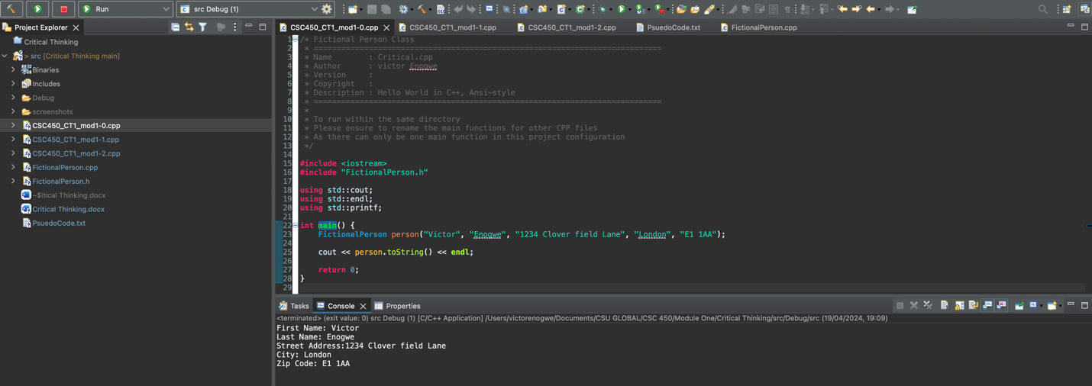

**Happy Path Execution Screenshot – Simple Program - CSC450_CT1_mod1-1-execution-output:**

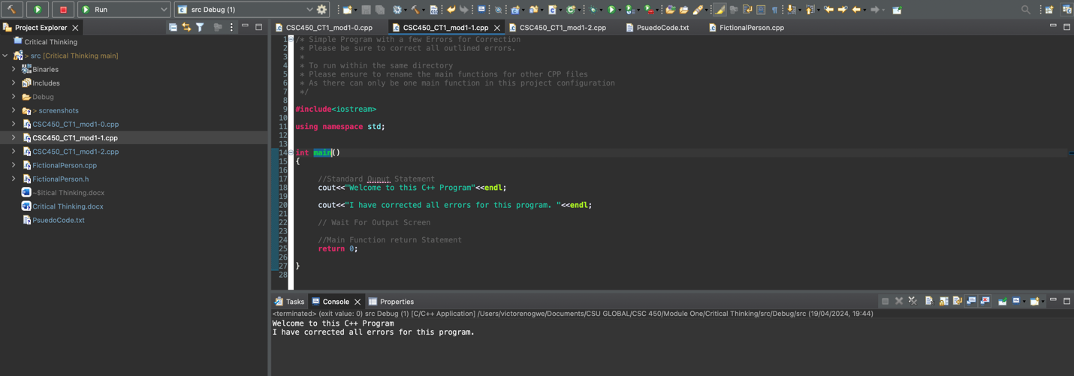

**Happy Path Execution Screenshot – Simple Program - CSC450_CT1_mod1-2-execution-output:**

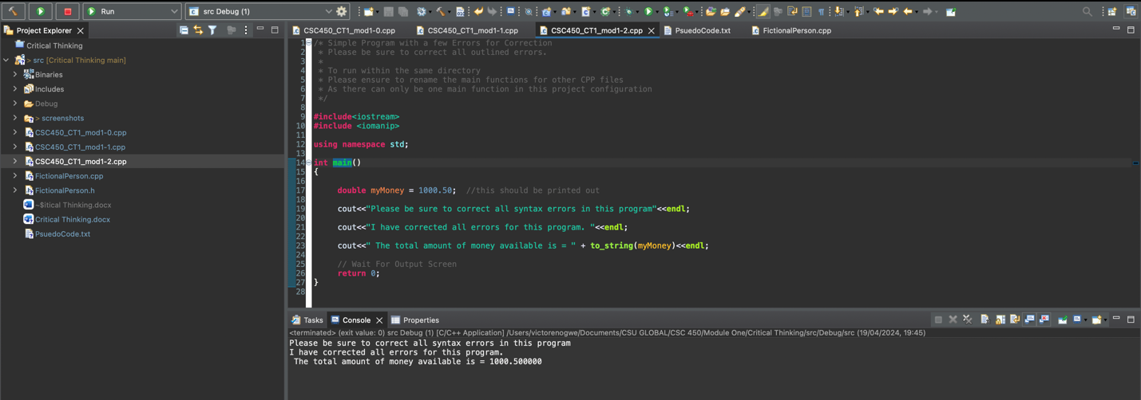

References